Olist E-Commerce Data Pipeline
Project Proposal, Module 2 Assignment
Dataset analysis, data cleaning methodology, architecture and design rationale, and a five-member team delivery plan.

1. Use Case and Business Objective
Olist is a Brazilian ecommerce marketplace that connects independent sellers to customers across Brazil. This project provides business and technical stakeholders with a single, trustworthy source of order, customer, product, and delivery data, replacing ad hoc, one-off data pulls.
The system is built to answer the same recurring questions reliably: is revenue growing, which products and regions drive it, is delivery performance hurting retention, and which customers are worth retention investment. Every design decision below serves that need, not an abstract technical exercise.
This objective directly shapes four choices made later in this document:
- The star schema (Section 4) is built around these recurring questions, not the source system's normalized structure, so answering them doesn't require a bespoke join chain each time.
- The derived metrics (Section 4) precompute the building blocks these questions need repeatedly, instead of recalculating them ad hoc.
- The data quality layer (Section 4) exists because decisions made on wrong numbers damage trust with the CEO- and CTO-level audience the brief specifies.
- The six analyses (Section 2) are the direct, named answers to this objective, not an arbitrary exploratory list.

Structuring and optimizing for this use case
The technical decisions outlined below follow from the specific requirements of this use case, rather than generic best practices applied without context. The considerations are addressed first, followed by the resulting design decisions.
Consideration | What this use case actually needs | Resulting decision
Time horizon / recency | Recurring questions (this month's revenue, top categories) care about the current period, not the full archive. Only the trend analysis needs the full date range, to show change over time. | fact_order_items is partitioned by purchase date. Period-scoped queries touch only relevant partitions; the trend analysis scans all of them deliberately.
Caching | The same six analyses rerun repeatedly, in development and again at the live exec presentation, not one-off ad hoc queries. | BigQuery's native result cache fits this at zero setup cost. A dedicated cache isn't built; it would only pay off under concurrent live-dashboard traffic, which this project doesn't have.
Cost and complexity | A two-week student project on a small, bounded dataset. Enterprise-scale infrastructure would sit unused, not add resilience. | BigQuery's free tier is the intended ceiling, not a stepping stone. Spark, Kafka, a dedicated cache, and incremental processing are excluded elsewhere for the same reason.
Consistency | Analyses run against fully materialized dbt tables after a completed run, never mid-load. No one queries the marts while Meltano or dbt is writing to them. | No additional consistency guarantees are built beyond dbt's run-then-query pattern. Load and query never happen concurrently, so this isn't a requirement the use case actually has.
Availability | The pipeline needs to be reliable during the team's working sessions and the live exec demo, not continuous uptime for external users. | BigQuery's published 99.99% SLA (Section 4) comfortably exceeds this. This is a bundled feature of the warehouse choice made for broader strategic reasons.
Beyond the schema shape itself, the following technical decisions were made specifically because of how this data will be queried.
Optimization area | Decision | Why it serves this use case
Partitioning | fact_order_items is partitioned by purchase date. | The monthly-trend question filters by date range every run. Partitioning limits it to relevant partitions instead of scanning the whole table. Savings are small today, but this avoids a redesign if volume grows.
Clustering | fact_order_items is clustered by product category and customer state. | The top-category and geographic-revenue questions filter and group by exactly these columns, so clustering scans less data for them at zero setup cost.
Materialization | Mart models (fact_*, dim_*) are materialized as dbt tables, not views. | The six analyses query the same marts repeatedly. A view would recompute the full transform every time; a table computes it once per dbt run and serves every query after that directly.
Query caching | BigQuery's native result cache is relied on as-is; no separate caching layer is built. | BigQuery serves cached results free when an identical query reruns within 24 hours, exactly what happens when a notebook is reopened and rerun. A dedicated cache would need concurrent live-dashboard traffic this project doesn't have.
Incremental processing | Not used; every dbt run processes the full dataset. | Incremental models exist to skip reprocessing unchanged history against new daily arrivals. Olist's data is static with no new rows, so there's no unchanged past to skip.
Pre-aggregated summary marts | Optional: one small mart_monthly_gmv model, if time allows. | The six questions are fixed and known in advance, so a small summary table for the most-rerun one avoids repeating that aggregation. Optional, given the two-week timeline.

Optional data enrichment
The assignment brief allows optional external data to enrich the dataset. The table below provides a list of optional APs that can possibly be used to try out REST APIs
tied to specific analyses for the project team to evaluate.
Source | What it is | Use in our use case | API
Banco Central do Brasil (BCB) PTAX | Brazil's central bank; free daily/monthly exchange rates, no key required. | Adds BRL-to-USD rates to dim_date, allowing GMV to be reported in USD for a general audience. | olinda.bcb.gov.br/olinda/servico/PTAX/versao/v1
IBGE (regional / population) | Brazil's statistics bureau; free public API. | Adds population to dim_customer or dim_geolocation, turning geographic revenue into revenue per capita. | servicodados.ibge.gov.br
IBGE (IPCA inflation) | Same source, a different series in the same API family. | Distinguishes real revenue growth from nominal growth in the monthly GMV trend. | servicodados.ibge.gov.br
BrasilAPI (holidays) | Free public API of Brazilian national holidays, no key required. | Adds is_holiday and holiday_name to dim_date, separating real demand shifts from holiday effects. | brasilapi.com.br/api/feriados/v1/{year}
Open-Meteo (historical weather) | Free, no-key, global historical weather API, verified back to 1940. | Tests whether weather conditions predict delivery delays, providing an additional variable for analysis. | open-meteo.com (Historical Weather API)
Google Trends | Search-interest data. Not recommended. | No stable official free API exists, and 2016-2018 historical search volume isn't retrievable this way regardless. | No viable endpoint; excluded
One option is deliberately not on this list: seller-to-customer delivery distance isn't an API at all, since both parties' coordinates already exist in dim_geolocation. It's a Haversine formula computed directly in SQL, not an external call.

2. Dataset Analysis
The Olist Brazilian E-Commerce dataset consists of nine relational CSV files, approximately 52 columns in total, covering approximately 100,000 orders placed between 2016 and 2018 through a Brazilian marketplace connecting independent sellers with customers. The data is already normalized across multiple tables, which aligns with the objective of this assignment: to reconstruct a coherent relational schema rather than ingest a single flat file.

Tables and grain
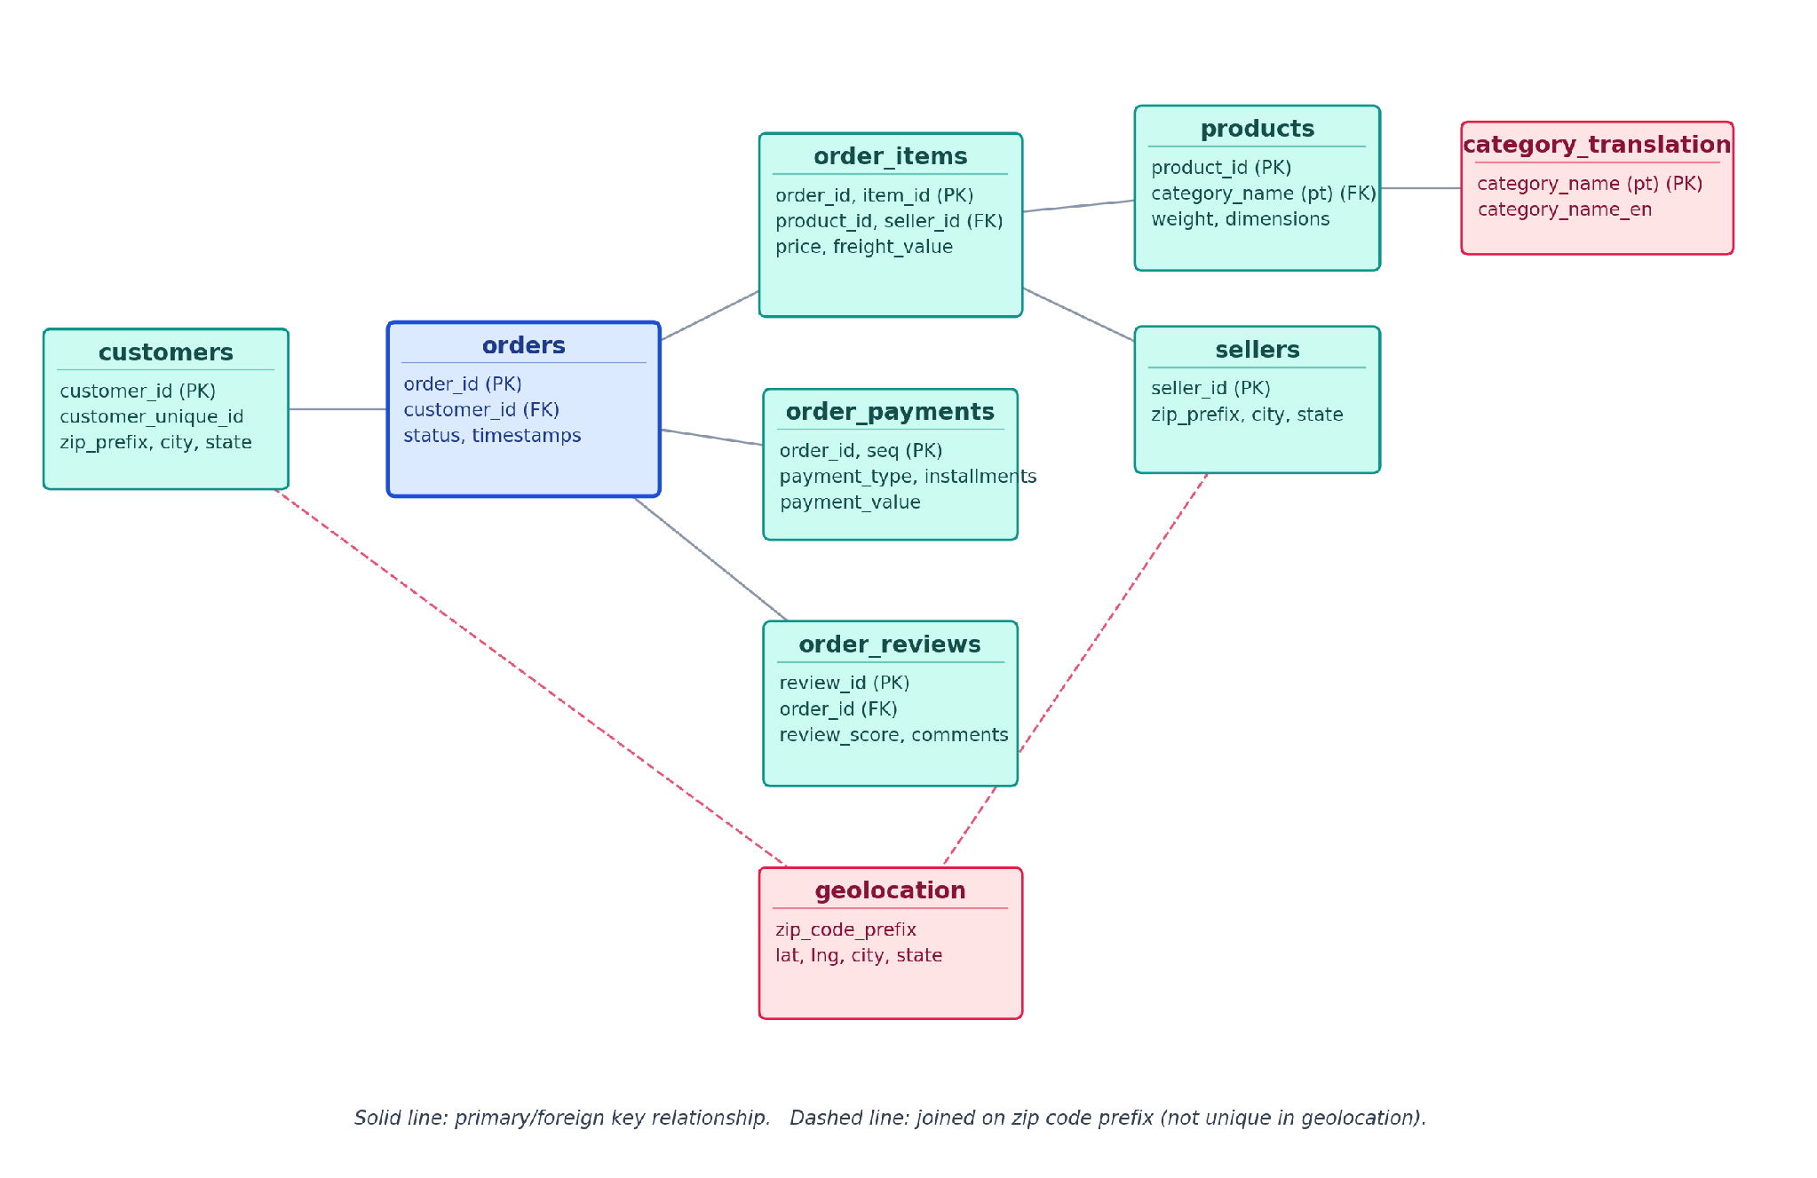
Figure 1. Source schema: how the nine raw Olist tables relate before transformation.

Data quality considerations
- The field customer_id is unique per order but does not persist across orders; customer_unique_id must be used for customer-level analysis such as segmentation, RFM, or repeat-purchase rate. Published analyses frequently cite a low repeat-purchase share of approximately 3 percent, accounting for 5 to 6 percent of revenue, which should be confirmed once the loaded data has been profiled.
- The relationships between orders and order items, and between orders and payments, are both one-to-many. A direct join across these relationships produces row duplication and results in double-counted revenue. The order_item level should therefore be used as the primary fact grain, with payments modeled as a separate fact table.
- The order_status field requires an explicit, documented business rule before gross merchandise value is calculated, as not every order record represents a completed sale, and without a consistent rule, GMV figures will vary depending on which statuses are included.
- The geolocation table contains multiple rows per zip code prefix and should be aggregated, for example using median latitude and longitude values, before being joined as a dimension table, as joining without aggregation duplicates rows in the fact table.
- Product category names are recorded in Portuguese and should be joined against the product_category_name_translation table early in the transformation process, so downstream reports show English labels rather than Portuguese ones.
- Order volume in 2016 is minimal, with data effectively beginning in September of that year. This sparsity should not be interpreted as seasonal variation in any trend analysis, or the ramp-up will read as a real demand spike. Note: can consider excluding this period
- Delivery timestamp fields contain null values for undelivered or canceled orders and require careful handling in any delivery-performance calculation, or the calculation will run on a biased subset of completed deliveries only.

Analytical approach
- All eleven tables should be profiled first, including row counts, null percentages, and referential integrity checks, before any schema design work begins, since skipping this risks discovering broken assumptions after models are already built on top of them.
- The fact grain and relevant business rules should be defined explicitly by the full team before any transformation code is written, since skipping this risks the same metric producing different numbers depending on which model calculated it.
The table below maps each planned analysis to the business question it answers, why it matters, and the source data required to compute it.
Analysis | Business question | Why it matters | Source data & notes
Monthly GMV and order trend | Is the business growing, flat, or declining month over month? | The base trajectory metric executives ask about first; frames every other finding. | fact_order_items (order_item_total, purchase_date_id) joined to dim_date (year, month), filtered by the order_status business rule. If the holiday API is adopted, dim_date's is_holiday flag distinguishes genuine demand dips from holiday effects.
Top-performing categories and products | Where is revenue concentrated? | Directly informs inventory and marketing prioritization; explicitly required by the brief. | fact_order_items (order_item_total) joined to dim_product (category_name_en, product_id), grouped and ranked by revenue.
Average order value (AOV) | Are customers buying more per order over time? | A revenue lever distinct from order count. | fact_order_items (order_id, order_item_total), aggregated to order grain before averaging, since averaging at item grain understates AOV on multi-item orders.
Delivery performance vs. review score | Does late delivery predict poor reviews? | Quantifies an operational risk as a revenue risk; the strongest business finding the pipeline can produce. | fact_order_items aggregated to order grain (average delay_days per order) joined to fact_reviews (review_score) via order_id; joining at item grain first would duplicate review_score once per item on the order. If the holiday API is adopted, dim_date's is_holiday flag also lets this be tested against peak shopping periods specifically.
Geographic revenue by state | Which regions drive revenue, and which underperform? | Surfaces where logistics or marketing investment would have the most impact. | fact_order_items (order_item_total) joined to dim_customer (state); customer state, not seller state.
RFM-based customer segmentation | Which customers are worth retention investment versus one-time buyers? | Follows directly from the customer_unique_id finding in Data Quality Considerations, tying the two sections together. | fact_order_items (order_id, purchase_date_id, order_item_total) joined to dim_customer (customer_unique_id, lifetime_spend). Recency = days since last order; frequency = distinct order count; monetary = lifetime_spend.
The full target schema, including these fields, is shown in Figure 4 (Section 4).

3. Data Processing and Cleaning Plan
Data cleaning in this project is implemented as a sequence of staged, independently testable transformations rather than a single script, converting the raw mirror of the source CSV files into reliable inputs for the star schema. Each step below specifies the required action, its rationale, and the tool used to implement it. An optional step 0, fetching the enrichment APIs listed in Section 1, writes its results as CSV files that then flow through the same six required steps as the core Olist data, via the same Meltano ingestion path, rather than needing separate tooling.
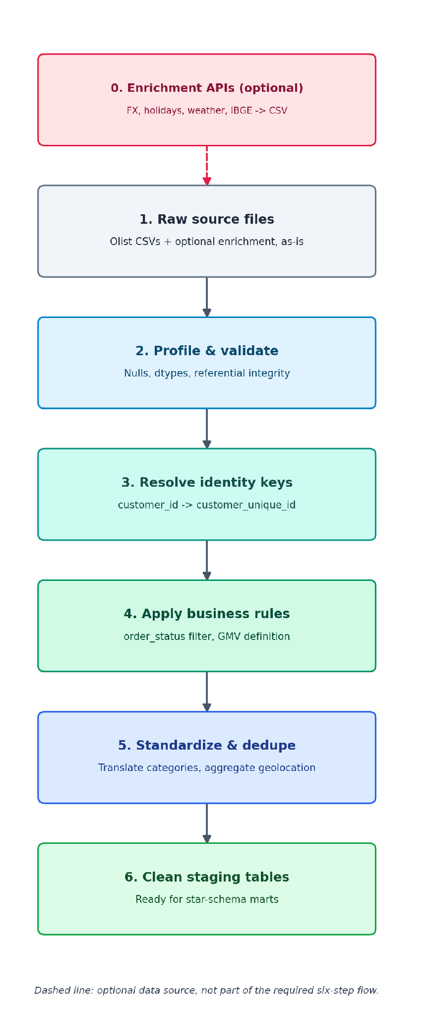
Figure 2. Data processing and cleaning flow, from raw source files to clean staging tables.
# | Step | Rationale | Implementation
1 | Load raw data without modification | Preserves an audit trail and a single source of truth, allowing downstream data to be re-derived without re-acquiring the source files. | Implemented via Meltano (tap-csv to target-bigquery), loading one raw table per CSV file into a BigQuery dataset named raw. The load_id and load_timestamp columns are added automatically for traceability.
2 | Profile and validate the raw data | Identifies structural data issues before transformation logic is written, ensuring that downstream mart models are not built on incorrect assumptions. | Performed using a DuckDB/Python profiling notebook to calculate null percentages and data-type summaries, and to identify orphaned rows via an anti-join between order_items and orders. Results are recorded in the data quality report.
3 | Resolve customer identity keys | Ensures that all customer-level metrics, including RFM segmentation and repeat-purchase rate, are calculated on the correct customer identifier rather than the order-level customer_id. | Implemented as a dbt staging model, stg_customers, which retains both identifier columns. The dim_customer dimension table is keyed on customer_unique_id.
4 | Apply the order-status business rule | Establishes an unambiguous and defensible basis for GMV and revenue figures, which would otherwise depend on an undocumented interpretation of order_status. | Implemented as a single, documented dbt macro or WHERE clause defining which order statuses constitute a completed sale, referenced consistently across all relevant models.
5 | Standardize and deduplicate reference data | Addresses Portuguese-language category labels and duplicate geolocation records, both of which otherwise compromise downstream joins and reporting. | Implemented as two dbt staging models: stg_products, which joins the category translation table, and stg_geolocation, which aggregates the source data to one row per zip code prefix using, for example, median latitude and longitude.
6 | Finalize clean staging tables | Establishes the handoff point between the data-cleaning workstream and star-schema construction. | Staging models (stg_*) are materialized in a dedicated staging BigQuery dataset and validated with dbt tests before any mart model is permitted to reference them.

4. Architecture Proposal and Rationale
The proposed architecture follows this sequence: source CSV files from Kaggle are loaded via Meltano into a BigQuery raw layer; dbt transforms this data into a star schema; dbt tests and Great Expectations validate data quality; pipeline orchestrated by Github Actions via CI/CD; finally with a quality data ready for analysis, DuckDB and Polars consumes the resulting mart tables. DuckDB and Polars support the analysis layer; Spark and Kafka are addressed separately below rather than built into the pipeline.
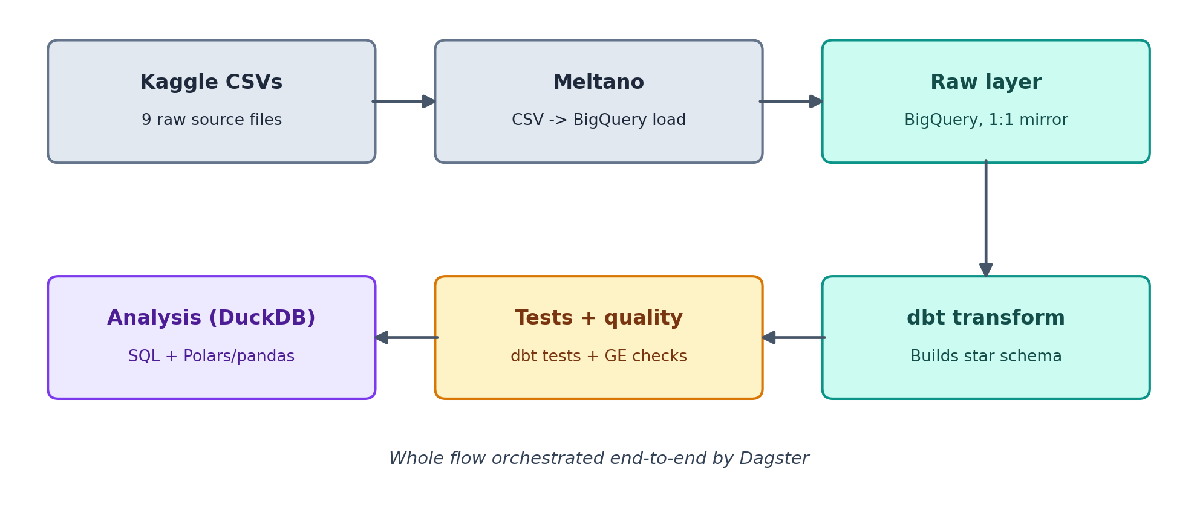
Figure 3. End-to-end architecture, from source data to analysis layer.

Pipeline component | Possible tools | Selection Rationale | Implementation
Extract and load | Meltano; hand-rolled Python script; Airbyte | Meltano (tap-csv to target-bigquery) is a standard extract-and-load pattern for moving flat files into a cloud warehouse; neither alternative offers additional benefit at this data volume. | The meltano.yml configuration file is set up with the nine source CSV files as streams for tap-csv. The BigQuery project and dataset are specified in the target-bigquery loader configuration, and the command ‘meltano run tap-csv target-bigquery’ is executed to extract the nine source CSV files as individual streams and load them into BigQuery raw dataset, maintaining a one-to-one mapping between the source streams and raw tables.
Warehouse | BigQuery; local Postgres in Docker; Snowflake | BigQuery has a free sandbox tier, that removes cost and setup friction across five separate accounts, it has a native dbt adapter, and it gives a credible cloud-scale narrative for the executive presentation that a local Postgres instance would not support. Snowflake was not pursued, since it offers no advantage here over the rest. | Separate raw, staging, and marts datasets are created within BigQuery. Each team member is granted Editor access, and credentials are maintained in a shared, non-version-controlled .env file referenced by both Meltano and dbt.
Transform | dbt; raw SQL scripts; pandas-based transform | dbt's load-then-transform approach preserves a permanent, re-runnable raw layer, and its built-in testing and documentation features satisfy two of the assignment's grading criteria largely without extra effort, which neither alternative provides by default. | The dbt project is initialized and profiles.yml is configured for BigQuery. Staging models (stg_*) are created for each source table under models/staging/, and fact_order_items, fact_payments, fact_reviews, and the dim_* models are created under models/marts/.
Data quality | dbt tests + Great Expectations, combined; either tool alone | dbt tests address schema-level validation, while Great Expectations addresses business-rule validation dbt cannot express as cleanly; relying on either alone would leave one of these two validation types uncovered. | dbt owns deterministic warehouse checks—keys, nulls, relationships, model grain, join fanout, and reconciliations—while Great Expectations owns business plausibility and monitoring on staging data. The dedicated testing strategy below defines table coverage, severity, and execution order; dbt relationships replace GX membership lists for foreign-key checks.
Analysis | SQLAlchemy + pandas (required); DuckDB + Polars, added; pandas alone | SQLAlchemy and pandas are specified directly in the assignment brief. DuckDB and Polars are added for heavier queries, since pandas alone would require loading the full dataset into memory for every aggregate query. | A SQLAlchemy engine (via the sqlalchemy-bigquery dialect) provides the pandas-based connection to the warehouse specified in the brief. DuckDB is used alongside this for larger aggregate queries and Polars for heavier in-memory transforms; pandas remains the format for final chart-ready dataframes.
Orchestration | GitHub Actions; Dagster; Airflow; plain cron | GitHub Actions provides CI/CD and server-side execution environments, with a good balance between automation, reliability, and operational simplicity. The project's pipeline has a relatively straightforward dependency structure which can be executed sequentially. GitHub Actions also integrates directly with GitHub repository, allowing the use of the same development environment. Dagster or Airflow provide more sophisticated data-pipeline features and capabilities, but introduce additional infrastructure and operational complexity unnecessary for our current pipeline. | Scheduled GitHub Actions workflows provide the orchestration mechanism for executing the data ingestion, transformation, and data-quality stages in sequence; and allows managing of pipeline code, testing, execution logs, and deployment-related workflows.
Documentation | dbt docs (auto-generated); manually written documentation | dbt docs is generated directly from the models with no extra effort and stays in sync as models change; hand-written documentation would need to be manually kept up to date. | Generated using dbt docs generate followed by dbt docs serve. This document, or an accompanying draw.io or Excalidraw export, serves as the authoritative architecture diagram.

Data quality testing strategy
The quality gate covers all nine Olist CSV tables and the two holiday API tables, then verifies that staging and mart models preserve their intended business grain. The design gives each rule one owner so the team does not maintain the same assertion twice.

Test ownership
- dbt owns deterministic warehouse correctness: required fields, primary and compound keys, relationships, accepted values, model grain, join fanout, transformation logic, and reconciliation between staging and marts.
- Great Expectations (GX) owns business plausibility and monitoring on staging data: numeric ranges, timestamp sequences, completeness rates, geographic plausibility, distribution changes, and operational quality observations.
- Critical failures stop the pipeline. Known source limitations and legitimate business outcomes are recorded separately as observations and reviewed in the data quality report.

Test coverage by data area
The table assigns structural tests to dbt and business-quality checks to GX. The same rule is repeated only when it protects a different layer or model grain.

Data area | dbt tests | GX checks
Customers and sellers | Keys, required fields, orders-to-customers relationship, and declared data types. | Brazilian state codes, ZIP representation, populated locations, and geographic-distribution changes.
Orders | Unique order key, customer relationship, required status and purchase timestamp, plus transformation unit tests. | Timestamp sequence, status-dependent delivery completeness, late-delivery rate, and order-volume changes.
Order items | Unique (order_id, order_item_id), relationships to orders/products/sellers, and valid item sequence. | Positive price, non-negative freight, valid item number, and price/freight/items-per-order distributions.
Payments and reviews | Unique compound grains and relationships to orders; review_id is not tested as unique alone. | Non-negative payments, valid payment type/installments, review score 1–5, answer timing, and distribution changes.
Products and categories | Unique product and translation keys; category relationship as a warning; category-fallback unit test. | Non-negative measurements and monitoring of missing categories, measurements, zero weights, and outliers.
Geolocation and holidays | One ZIP row after geolocation aggregation; unique holiday date/year with required reference fields. | World-valid coordinates plus duplicate, Brazil-region, and coverage monitoring; no duplicate GX holiday tests.
Marts | Fact/dimension grain, foreign keys, join fanout, derived metrics, and reconciliation to staging. | Business KPI monitoring only where it adds a time-based signal; structural mart rules remain in dbt.

Known baseline and severity
Profiling of the local source files identified conditions that should not become permanent blocking failures without an agreed cleaning rule or exception:
- 261,831 exact duplicate geolocation rows; staging must aggregate them before dimensional joins.
- 814 repeated review_id values; the correct review grain is (review_id, order_id).
- 623 product rows use two categories absent from the translation table, and 610 products have missing category or descriptive fields.
- 278 customer rows and 7 seller rows reference ZIP prefixes absent from geolocation.
- 166 carrier timestamps precede purchase, 23 customer-delivery timestamps precede carrier delivery, and 1,190 order payment totals differ from item price plus freight by more than one cent. These begin as observations while the team defines valid exceptions.
Critical tests use zero tolerance for broken keys, unexpected core orphans, negative monetary values, scores outside 1 to 5, and mart grain or reconciliation errors introduced by transformation logic. A separate observation checkpoint keeps known source anomalies visible without making every scheduled run fail.

Execution order
- Meltano loads the raw tables into BigQuery.
- dbt builds staging models and runs structural tests.
- GX runs a blocking critical checkpoint against staging, followed by a non-blocking observation checkpoint.
- dbt builds intermediate and mart models and runs grain, relationship, unit, fanout, and reconciliation tests.
- Github Actions runs pipeline automation, records execution logs and failure status, and prevents downstream processes when a critical gate fails.

Repository locations
Each staging model keeps its tests and documentation in a same-named YAML file beside its SQL model. Cross-model singular tests live in dbt_transform/tests/. GX suites and checkpoints persist under gx/, while repeatable setup and execution code lives under scripts/. The notebook is used to develop expectations rather than as the scheduled production entry point.

Star schema design
The proposed schema uses three fact tables sharing a common set of dimensions, a pattern known as a fact constellation, rather than a single fact table. The primary fact, fact_order_items, is at order-item grain and contains price, freight, and quantity measures. It is surrounded by five dimension tables: dim_customer, dim_product, dim_seller, dim_date, and dim_geolocation.
dim_date is referenced three times from fact_order_items, once each for the purchase date, delivered date, and estimated delivery date. This follows the standard role-playing dimension pattern rather than adding a separate date table for each.
fact_payments and fact_reviews are kept as separate, conformed fact tables rather than merged into fact_order_items. order_items and order_payments are each independently one-to-many with orders: an order can have multiple items and, separately, multiple payments, such as a split installment, so no single grain fits both without duplication. Joining items directly to payments would produce every item-payment combination and overstate revenue; a separate fact table per business event, each at its own grain, avoids this.
Both satellite facts also connect directly to dim_customer and dim_date, rather than relying on a join through fact_order_items to reach them. fact_order_items is at order-item grain, while fact_payments and fact_reviews are at order grain; routing a query through fact_order_items would duplicate every payment or review once per item on the order. The existing order_id relationship between the fact tables is kept for drill-through only, not as the primary query path.
This approach follows established dimensional modeling practice (the Kimball methodology) and satisfies the assignment's requirement for a schema that supports efficient, straightforward analytical querying.

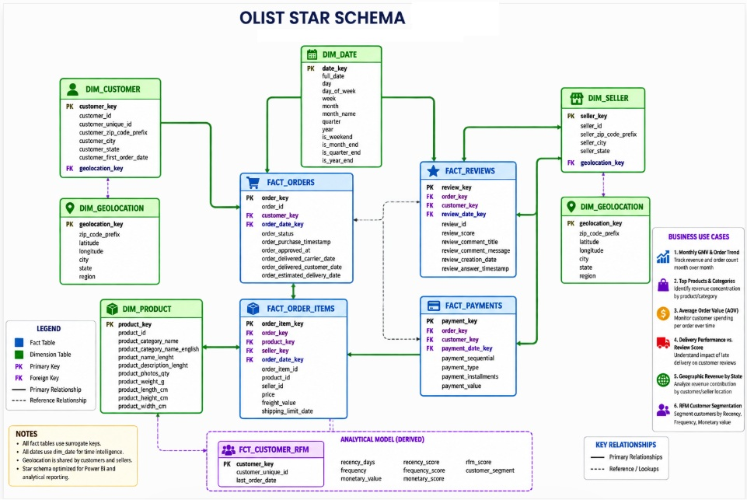
Figure 4. Star schema for the Olist warehouse with keys

Derived metrics
The dbt transform layer computes three derived columns:
- A total order-item amount, calculated as price plus freight_value, is computed as a column on fact_order_items. This is specified directly in the assignment brief.
- A running customer lifetime spend, computed as a cumulative sum of order totals per customer_unique_id over time, is maintained as a derived column on dim_customer. This is also specified directly in the assignment brief.
- A delivery delay in days, calculated as the difference between the delivered date and estimated delivery date, is computed on fact_order_items to support the delivery-performance analysis described earlier in this document.
All three are implemented using standard dbt aggregate and window-function logic and are validated by the same test suite applied to the rest of the mart layer.

Tools considered and not implemented
Apache Spark is not used in this pipeline. Spark distributes computation across a cluster when data volume exceeds the capacity of a single machine, regardless of whether it is used in an ETL or an ELT pattern; Spark is commonly used within ELT pipelines as well, including via the dbt-spark adapter, so its exclusion here is a question of data volume rather than pipeline architecture. The Olist dataset totals approximately 50 to 100 megabytes across all nine files, well below the threshold at which distributed computation becomes necessary, and BigQuery already executes the dbt transformations as distributed SQL. Introducing Spark at this volume would add a second distributed engine on top of one already in use, without addressing any actual constraint.
Kafka is also not used. Kafka is designed to consume a live event stream; the Olist dataset is a static historical export rather than a live order feed, and no such stream exists. Simulating one by replaying static records would constitute an artificial construct rather than a reflection of the underlying data source.
At current data volume, BigQuery and dbt already provide distributed query execution without requiring a dedicated Spark cluster. Should order volume increase substantially, the dbt transformation layer could be extended to use PySpark on Dataproc for computationally intensive joins. Similarly, if this pipeline were connected to Olist's live production system rather than a static historical export, order, payment, and review events would arrive as a continuous stream and could be captured using Kafka and Spark Structured Streaming to support near-real-time reporting in place of nightly batch processing.
Addressing these tools in this manner demonstrates an understanding of the conditions under which each would be appropriate, which represents a stronger response to the architecture-and-scalability grading criterion than their premature implementation. This approach requires two paragraphs of documentation rather than several days of unnecessary development effort.

5. Setup and Prerequisites
The items below must be in place before Week 1 work begins. None of this is optional groundwork; several of these tools do not appear elsewhere in this document by name, since the architecture section describes what each tool does rather than what needs installing.
Category | Requirement | Notes | Who needs this
Accounts | Google Cloud Platform project, with BigQuery enabled | Free sandbox tier covers this dataset's size; each team member needs Editor access granted. | Whole team
Accounts | GitHub repository | Single main branch, per the deliverables list. | Whole team
Environment | Python virtual environment | Given the number of packages involved below, an isolated environment per team member is worth setting up first. | Everyone
Environment | Meltano, with the tap-csv and target-bigquery plugins | Extract-and-load layer. | A only
Environment | dbt, with the dbt-bigquery adapter | Transform layer; profiles.yml must be configured to point at the BigQuery project. | B and C primarily; D and E as needed
Environment | Great Expectations | Business-rule data quality checks, run alongside dbt's own tests. | C only
Environment | SQLAlchemy, with the sqlalchemy-bigquery dialect | The specific package that lets SQLAlchemy connect to BigQuery; not included in a default SQLAlchemy install. | D only
Environment | Dagster (and dagster-webserver, if using the UI) | Orchestration. | E only
Environment | Jupyter | Notebooks are an explicit deliverable, even though not named in the architecture table. | D only
Credentials | A BigQuery service account or OAuth credential | Kept in a shared, git-ignored .env file; referenced by both Meltano and dbt. This is a deliberate simplification over individual OAuth access per team member: it trades per-person attribution and differentiated permissions for one credential to set up instead of five. | Whole team (shared)
Data | The nine Olist CSV files, downloaded locally | tap-csv reads from local files, not directly from Kaggle. | A only
The tool for assembling the presentation deck remains to be finalized. The project team will determine the appropriate platform (e.g., PowerPoint or Google Slides) to support the Week 3 deliverables.

6. Team Plan: Five Members, Three Weeks
Owner / workstream | Responsibilities | Deliverable
A - Ingestion and infrastructure | BigQuery environment setup, configuration of the Meltano tap-csv to target-bigquery pipeline, repository scaffolding, and branch strategy. | A functioning raw data layer in BigQuery and an initialized GitHub repository maintained on a single main branch, as specified in the deliverables.
B - Data modeling | Star schema design (fact and dimension tables), dbt staging and mart models, and a written justification of the schema design. | A dbt project comprising staging and mart layers.
C - Data quality | dbt tests referential integrity and business-rule validation, and a data quality report. | A completed test suite and the data quality section of the final report.
D - Analysis and insights | Analysis notebooks (SQLAlchemy, pandas) covering revenue trends, average order value, top-performing products and categories, RFM segmentation, the correlation between delivery performance and review score, and supporting charts. | Completed analysis notebooks and chart assets for the written report and presentation.
E - Orchestration, documentation, and delivery | A Dagster orchestration job adapted from the reference implementation, the architecture diagram, compilation of the written report, and assembly and rehearsal of the presentation deck around its five required components: Executive Summary, Business Value, Technical Overview, Risks, and Q&A preparation. | Completed Dagster configuration, architecture diagram, final written report, and presentation deck.

Cross-training and learning breadth
The track ownership above maximizes parallel progress and keeps merge conflicts minimal, but on its own limits each member's hands-on exposure to roughly one tool. The additions below preserve that same ownership structure and the three-week timeline, while giving each member direct, hands-on exposure to at least one tool outside their own track.
Person | Home track | Cross-training task
A | Ingestion & infrastructure | Drafts stg_geolocation.sql.
B | Data modeling | Writes one Great Expectations check.
C | Data quality | Reviews one dbt mart model directly.
D | Analysis & insights | Pairs with E to define one Dagster asset.
E | Orchestration & delivery | Pairs with A on the Meltano configuration for one source table.
The schedule below targets full completion of all technical pipeline work by the end of Week 2. Week 3 is reserved for the written report, presentation deck, and rehearsal, work that does not depend on further pipeline changes, which means it also absorbs any technical task from Weeks 1-2 that ran over, without displacing already-scheduled work. This is realistic specifically because the star schema, architecture, and cleaning steps are already fully designed in this document; Week 1 begins by implementing an existing design rather than starting design work from a blank page.

Staging model assignment and dependencies
Before any staging model can be written, sources.yml must declare all nine raw tables, using the exact table names confirmed at merge. This is a single step, done once by whoever merges the pull request, before the assignments below begin.
Task | Who | Details | When | Dependencies
Write sources.yml | First person free once the branch is merged | Declares all nine raw tables as dbt sources, using the exact table names confirmed at merge | Sept 1-2, after merge | Final table names confirmed at merge
Write stg_order_items.sql | C | One-to-one staging model: rename and cast columns from raw order_items, no business logic | Sept 4-5 | sources.yml
Write stg_order_payments.sql | C | One-to-one staging model: rename and cast columns from raw order_payments | Sept 4-5 | sources.yml
Write stg_order_reviews.sql | C | One-to-one staging model: rename and cast columns from raw order_reviews | Sept 4-5 | sources.yml
Write stg_products.sql | C | One-to-one staging model: rename and cast columns from raw products | Sept 4-5 | sources.yml
Write stg_sellers.sql | A | One-to-one staging model: rename and cast columns from raw sellers | Sept 4-5 | sources.yml
Write stg_category_translation.sql | A | One-to-one staging model: joins Portuguese category names to English | Sept 4-5 | sources.yml
Write stg_geolocation.sql | A | Aggregates raw geolocation to one row per zip prefix, using median latitude and longitude. Review is open to whoever has time, not a fixed reviewer. | Sept 4-5 | sources.yml
Write stg_orders.sql | B, plus flexible support if the workload needs it | Applies the order_status business rule defining which statuses count as a completed sale | Sept 4-5 | sources.yml
Write stg_customers.sql | B, plus flexible support if the workload needs it | Resolves customer_id to customer_unique_id for correct customer-level analysis | Sept 4-5 | sources.yml
Each model's tests and documentation are defined in its own small YAML file next to its SQL file (for example, stg_orders.sql paired with stg_orders.yml), rather than one shared schema.yml for the whole folder. Multiple people editing one shared file at the same time is a predictable merge conflict; per-model files avoid it entirely.
stg_geolocation.sql is A's cross-training task from the table above, now pointed at a specific model rather than left generic.
A's PR review and merge responsibility is complete, so the two solo files and the geolocation draft are A's primary focus now, not work squeezed into review gaps. Once those are done, A is not tied to a fixed partner: she joins whichever team member has the heaviest remaining load at that point. The Meltano pairing with E in the cross-training table above is one candidate, not a guaranteed commitment; B's two remaining models are another, depending on how the evening has actually gone by then.

Alignment items
Step 1 covers the rapid-fire infrastructure and scope questions; Step 2 covers work-split confirmation. Schema review and lock is the main event and follows both.
Task | Details | Who | Dependencies | By when | Document section
Confirm dataset name | Decide raw or olist_staging as the landing dataset name; whichever it is, applies everywhere in the pipeline. | Whole team | Warehouse project confirmed | Sept 3, before schema review | Section 4, Warehouse row
Confirm table naming convention | Decide plain names (orders) or prefixed (raw_orders) for the nine raw tables; this is what B's dbt source() calls will reference directly. | Whole team | Dataset name confirmed | Sept 3, before schema review | Section 2, Figure 1; Section 4, Transform row
Confirm geolocation key handling | Decide keys: [] or the composite zip/lat/lng key for the geolocation entity. | A, B | None | Sept 3, before schema review | Section 2, Data quality considerations
Confirm authentication standard | Confirm OAuth-per-person (gcloud auth application-default login) is the standard, not a shared service-account key. | Whole team | Warehouse project confirmed | Sept 3, before schema review | Section 5, Credentials row
Confirm repo layout | Decide whether the data folder and .env file live at repo root or inside the Meltano project folder. | A | None | Sept 3, before schema review | Section 5, Data row
Confirm holiday API is in scope | Explicitly confirm whether the Brazil holiday API enrichment was actually agreed as team scope, not just started by one person. | Whole team | None | Sept 3, before schema review | Section 1, Optional data enrichment table
Confirm holiday API implementation approach | If in scope, decide CSV-intermediate (matching the documented Step 0 design) or direct tap-to-BigQuery (matching the current PR). | Whole team | Holiday API confirmed in scope | Sept 3, before schema review | Section 3, Figure 2 and Step 0 description
Confirm deck tool | Decide PowerPoint, Google Slides, or Canva for the presentation deck. | E, whole team | None | Sept 3, before schema review | Section 5, closing paragraph
Assign deck section authorship | Assign who writes the deck's unclaimed sections: Executive Summary, Business Value, Risks. DQ report (C) and schema justification (B) are already assigned. | Whole team | None | Sept 3, during work-split confirmation | Section 6, team ownership table and Week 3 bullets
Confirm analysis stack with D | Confirm SQLAlchemy plus pandas as the primary analysis connection, DuckDB as the one addition, and that Polars has been dropped entirely. | D | None | Sept 3, during work-split confirmation | Section 4, Analysis row
Confirm open review norm | Confirm review is open to anyone on the team, with no fixed reviewer assigned per file. | Whole team | None | Sept 3, during work-split confirmation | Section 6, cross-training and staging tables

Week 1: setup, schema lock, and staging (September 1-7)
- Tuesday, September 1 (today): the pull request is merged; team member A begins configuration immediately.
- Wednesday, September 2: B refines the star schema draft, C drafts the data quality rule set, D explores the raw BigQuery tables directly, and sources.yml is written once the merge confirms final table names.
- Thursday, September 3, after class: the full team reviews the proposed schema and locks it. This review should not be deferred, as subsequent work depends on it.
- Friday-Saturday, September 4-5: staging models are built per the assignment and dependency table above. In parallel, D sets up the SQLAlchemy and DuckDB connections to the warehouse and deepens the raw-table profiling for the specific columns the six analyses will need, rather than sitting idle until staging is complete.
- Sunday-Monday, September 6-7: B completes the materialized dbt mart models; C completes the Great Expectations checks; D begins analysis against staging and mart tables as they become available.

Week 2: analysis, orchestration, and technical completion (September 8-11)
- Tuesday, September 8, after class: a team walkthrough is held, where each owner demonstrates their piece of the pipeline to the other four. This is a technical checkpoint, distinct from the executive presentation rehearsal, which is scheduled separately in Week 3.
- Wednesday-Thursday, September 9-10: D finalizes charts and analytical findings using DuckDB; E adapts the Dagster example into a scheduled orchestration job; cross-training pairs (A with E, B with C, D with E) complete their tasks from the table above; C writes the data quality report section, and B writes the schema justification section of the report.
- Friday, September 11: E assembles the written report and an initial draft of the presentation deck, structured around its five required components: Executive Summary, Business Value, Technical Overview, Risks, and Q&A preparation. All technical pipeline components are complete and merged to main.

Week 3: reporting, deck, and rehearsal (September 12-16)
- Saturday, September 12, afternoon after class: the full team reviews the business-value and schema-justification sections of the report together.
- Sunday-Monday, September 13-14: the report and deck are refined based on Saturday's feedback.
- Tuesday, September 15, after class: the full team rehearses the presentation and anticipated questions. This is treated as a full dedicated session, not a brief discussion, given what is riding on it; there is no additional class-adjacent slot left before submission for a second round if one turns out to be needed.
- Wednesday, September 16: reserved for repository cleanup, any outstanding item, and submission.

LOCAL MACHINE

Olist CSV files
│
▼
tap-csv
(extractor)
│
▼
Meltano
(pipeline/orchestration)
│
▼
target-bigquery
(loader)
│
▼
GOOGLE CLOUD
│
▼
Project file
│
▼
olist_raw
│
┌────┴─────────┐
▼ ▼
Tables Raw data

